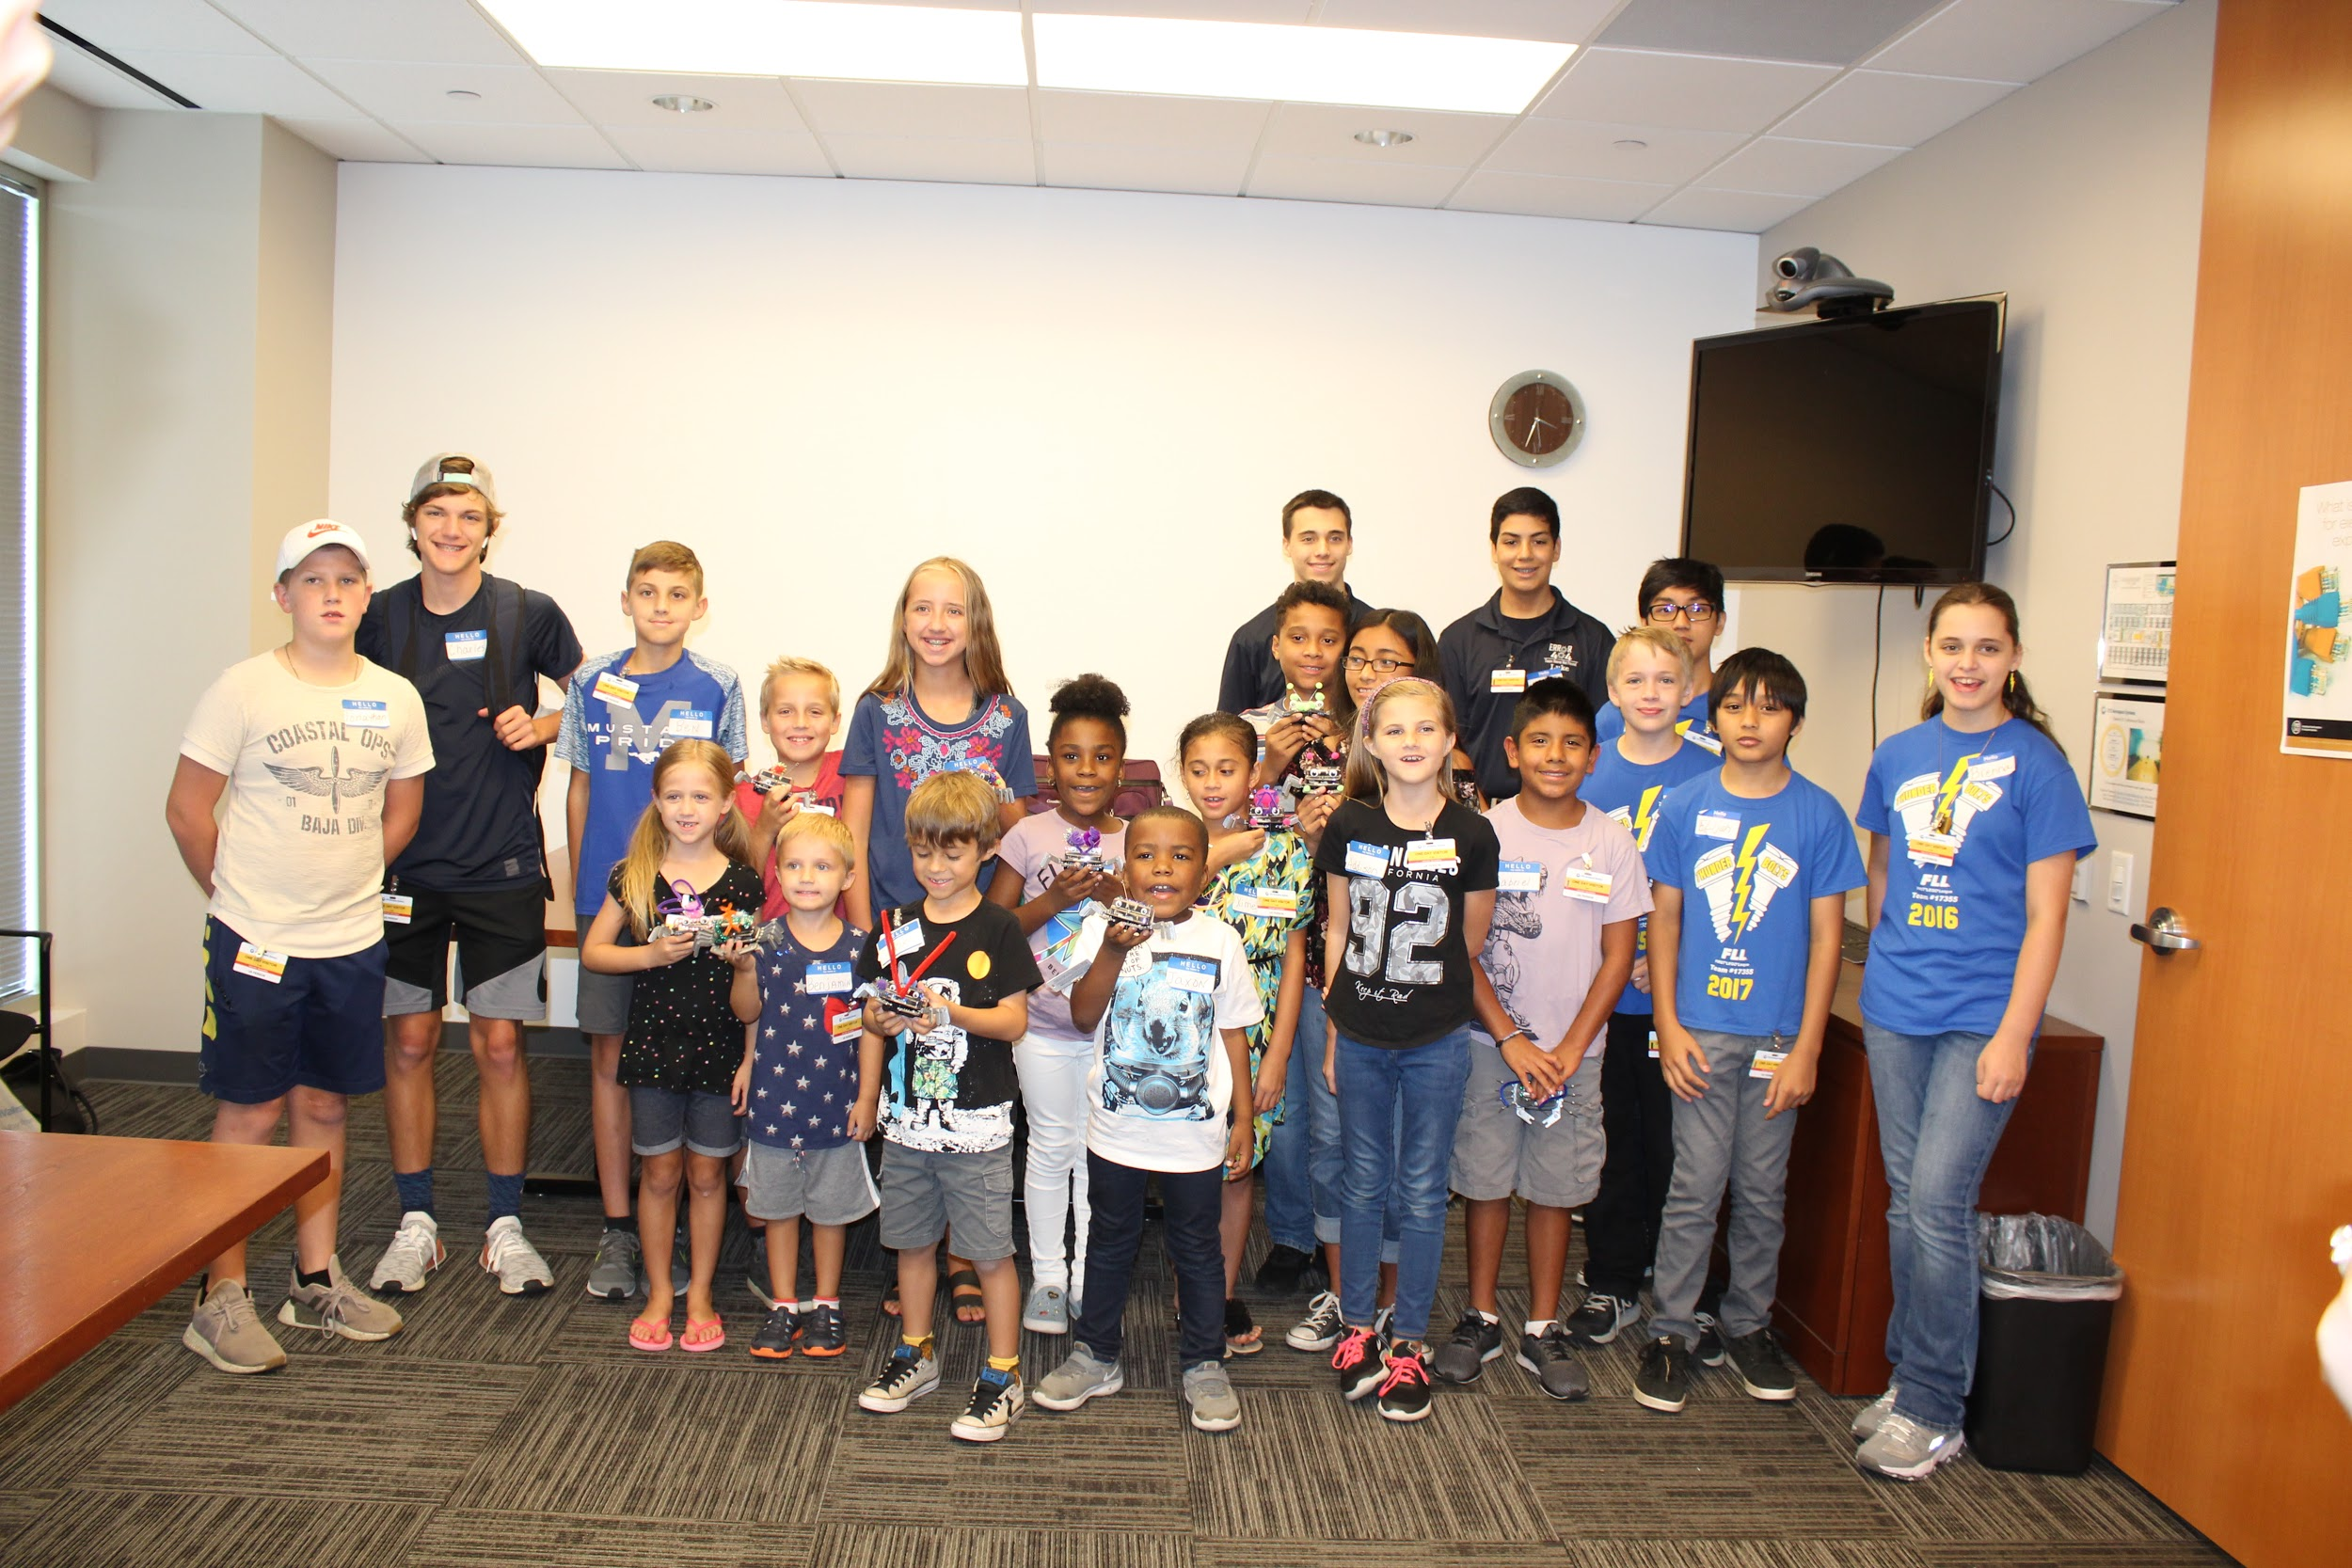
“Went Somewhere”

MM DD, 2018
From this time to this time

A short text description of the event and who was reached and how the team spread FIRST and FTC

Also add several pictures from the event. Preferably ones of the team engaging with the people at the event. Pictures speak a thousand words. Pick good pictures that vividly depict the event.

